4101607/4101707/4101907
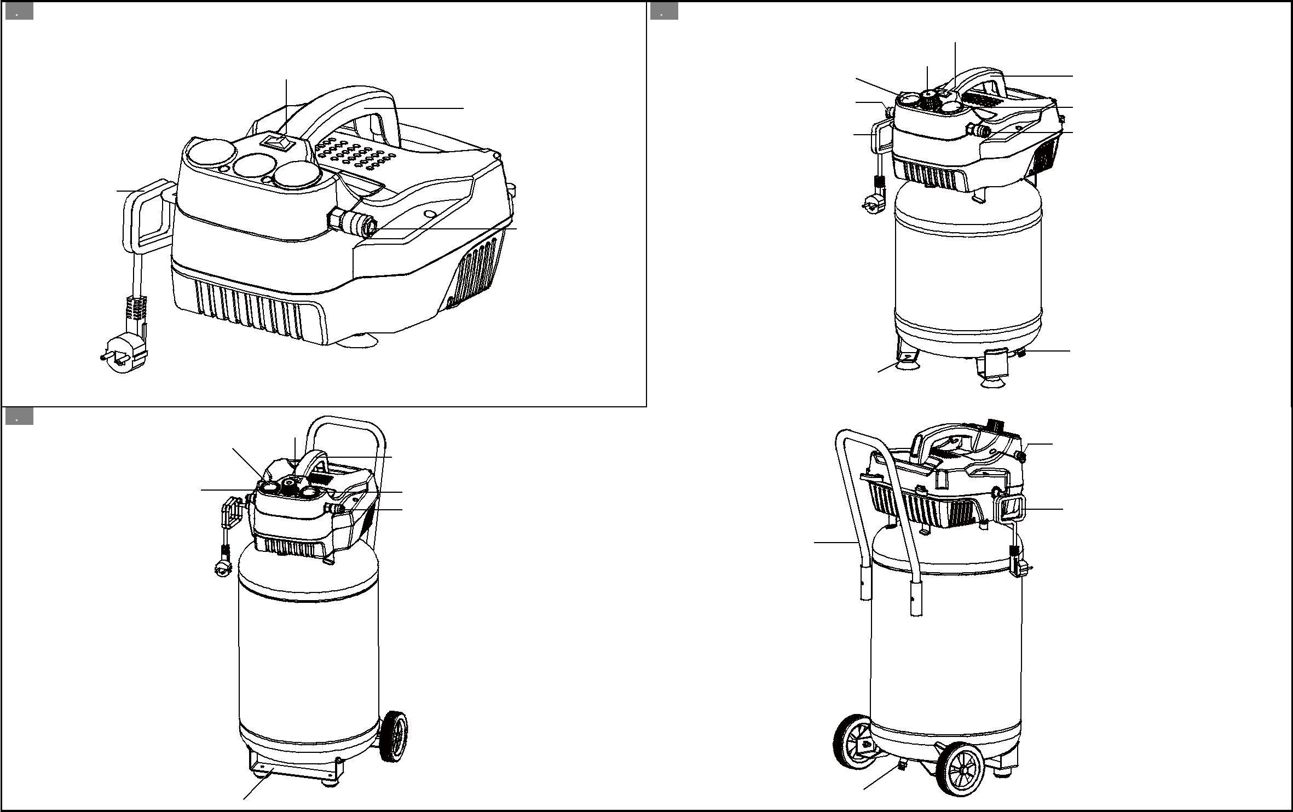

1. | 2.
 |  | 5 | 8
3 | 7 | 5 | 1
1 | 2 |  | 6
 | 10 |  | 3

4

2

 |  |  | 4
 |  |  | 9
 |  | 4101607 | 4101707
3. |  | 8 | 4.
 | 7 | 8 | 2
 | 7 | 1 | 2
5 |  | 6 | 10
 |  | 3 | 10
 |  |  | 11

9 ⁴ 4101907

